Supplementary Data
FIGURE S1―Recrystallized skeleton (ZPAL H.21/12) of Cuifia marmorea (Frech, 1890). A, B) Transmitted light and C, D) polarized light images. The septa are completely recrystallized and sparry crystal habits are visible both in the septal and interseptal regions (B, D: dashed lines mark septum boundary, black arrows indicate crystals crossing septum/sediment boundary); basic microstructural units (TD or RAD) are no longer recognizable.
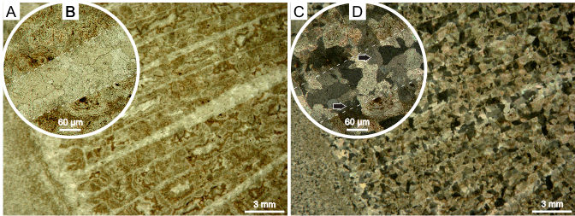
FIGURE S2―Micro-Raman maps of ZPAL H.21/4B. A) aragonite lattice mode at 203 cm⁻¹ (blue), B) calcite lattice mode at 283 cm⁻¹ (green; A, B: red arrows correspond to secondary aragoniote cement, white arrows correspond to RAD regions), C) combination of these two modes and D) carbonate lattice mode at 1085 cm⁻¹ (red) of transversely sectioned skeleton of Pachysolenia cylindrica. Image D is practically featureless which confirms that the skeleton is composed of calcium carbonate.
