Supporting Information

geobiological and diagenetic insights FROM A MALVINOKAFFRIC Devonian BIOTA (Chapada Group, Paraná Basin, Brazil): paleobiological and paleoenvironmental implications

Bruno Becker-Kerber^{1*}, Gabriel Ladeira Osés², Jessica Fleury Curado³, Márcia de Almeida Rizzutto⁴, Isaac Daniel Rudnitzki⁵, Guilherme Raffaeli Romero⁶, Silvio Yuji Onary-Alves⁷, Victoria Giopato Benini⁸, Douglas Galante⁹, Fabio Rodrigues¹⁰, Pedro Victor Buck¹, Elidiane Cipriano Rangel¹¹, Renato Pirani Ghilardi¹², Mírian Liza Alves Forancelli Pacheco⁸

¹. Programa de Pós-graduação em Ecologia e Recursos Naturais, Universidade Federal de São Carlos, São Carlos, Washington Luiz 325 km, CEP 13565-905, Brazil; bruno.becker92@gmail.com.
². Instituto de Geociências, Universidade de São Paulo, São Paulo, Rua do Lago 562, CEP 05508-080, Brazil.
³. Centro Universitário FEI, São Bernardo do Campo, Brazil.
⁴. Instituto de Física, Universidade de São Paulo, São Paulo, Rua do Matão, Travessa R 187, CEP 05508-090, Brazil.
⁵. Instituto de Astronomia, Geofísica e Ciências Atmosféricas, Universidade de São Paulo, Rua do Matão, 1226, 05508-090, São Paulo, Brazil
⁶.Instituto de Geociências, Universidade Federal do Pará, Campus Universitário do Guamá, Rua Augusto Correa Nº01. CEP 66075-110. Belém - PA - Brasil
⁷. Programa de Pós-graduação em Biologia Comparada, Laboratório de Paleontologia de Ribeirão Preto, Faculdade de Filosofia, Ciências e Letras de Ribeirão Preto, Departamento de Biologia, Universidade de São Paulo, Av. Bandeirantes, 3900 CEP 14040-901, Ribeirão Preto, São Paulo, Brazil.
⁸. Departamento de Biologia, Universidade Federal de São Carlos - campus Sorocaba, Rod. João Leme dos Santos km 110, CEP 18052-780, Sorocaba, São Paulo, Brazil.
⁹. Brazilian Synchrotron Light Laboratory, Brazilian Center for Research in Energy and Materials, Av. Giuseppe Maximo Scolfaro, 10000, CEP 13083-100, Campinas, Brazil.
¹⁰. Instituto de Química, Universidade de São Paulo, Av. Prof. Lineu Prestes, 748, CEP 05508-000, São Paulo, Brazil.
¹¹. Universidade Estadual Paulista Júlio de Mesquita Filho, Unidade Diferenciada Sorocaba, Av. 3 de março, 511, Alto da Boa Vista, 18087180, Sorocaba, SP – Brasil.
¹². LAPALMA/DCB/FC/UNESP- Bauru, CEP 17033-360, Bauru, São Paulo, Brazil
RRH: DEVONIAN INVERTEBRATES OF PARANÁ BASIN
LLH: B. BECKER-KERBER ET AL.

Table. S1. Classes of preservation of the invertebrate fossils analyzed in this study.
Classes of preservation | Linguliformean brachiopods | Rhynchonelliformean brachiopods | Trilobites
Preserved shell | 45 | 0 | 1
Molds with coatings | 0 | 57 | 8
Molds | 0 | 4 | 0

Table. S2. Collection numbers and localities of the samples considered in geochemical analyses.
Fossil | Collection Number | Geographic coordinates
Orbiculoidea 1 | CCLP1121 | 18°55'10" S - 54°48'53" W
Orbiculoidea 2 | CCLP1122 | 18°55'10" S - 54°48'53" W
Orbiculoidea 3 | CCLP1123 | 18°56'19" S - 54°50'12" W
Orbiculoidea 4 | CCLP1124 | 18°55'10" S - 54°48'53" W
Orbiculoidea 5 | CCLP1125 | 18°55'10" S - 54°48'53" W
Orbiculoidea 6 | CCLP1126 | 18°55'10" S - 54°48'53" W
Rhynchonellata 1 | CCLP1127 | 18°55'10" S - 54°48'53" W
Rhynchonellata 2 | CCLP1128 | 18°55'10" S - 54°48'53" W
Strophomenata 1 | CCLP1129 | 18°55'10" S - 54°48'53" W
Strophomenata 2 | CCLP1130 | 18°56'19" S - 54°50'12" W
Strophomenata 3 | CCLP1131 | 18°55'10" S - 54°48'53" W
Rhynchonelliformean brachiopod fragment | CCLP1132 | 18°55'10" S - 54°48'53" W
Calmoniid trilobite | CCLP1118 | 18°55'10" S - 54°48'53" W
Calmoniid trilobite within concretion | CCLP1119 | 18°56'19" S - 54°50'12" W

Table. S3. List of specimens from Malvinokaffric fauna found in Devonian outcrops (Alto Garças Sub-basin, Paraná Basin) and analyzed in this study.

Phyllum | Class | Family | Genus | Species
Brachiopoda | Rhynchonellata | Hysterolitidae | Australospirifer | Australospirifer sp.
 |  | Leptocoeliidae | Australocoelia | Australocoelia palmata
 | Strophomenata | Schuchertellidae | Schuchertella | Schuchertella sp.
 |  | Strophochonetidae | strophochonetids | strophochonetids
 |  | Chonetidae | chonetids | chonetids
 | Lingulata | Discinidae | Orbiculoidea | Orbiculoidea cf. baini
 |  |  |  | Orbiculoidea cf. bondenbenderi
 |  |  |  | Orbiculoidea cf. excentrica
 |  |  | Gigadiscina | Gigadiscina sp.
 |  |  | Rugadiscina | Rugadiscina sp.
 |  | Lingulidae | lingulids | lingulids
Arthropoda | Trilobita | Calmoniidae | Calmonia | Calmonia sp.
 |  |  | Metacrypheus sp. | Metacrypheus sp.

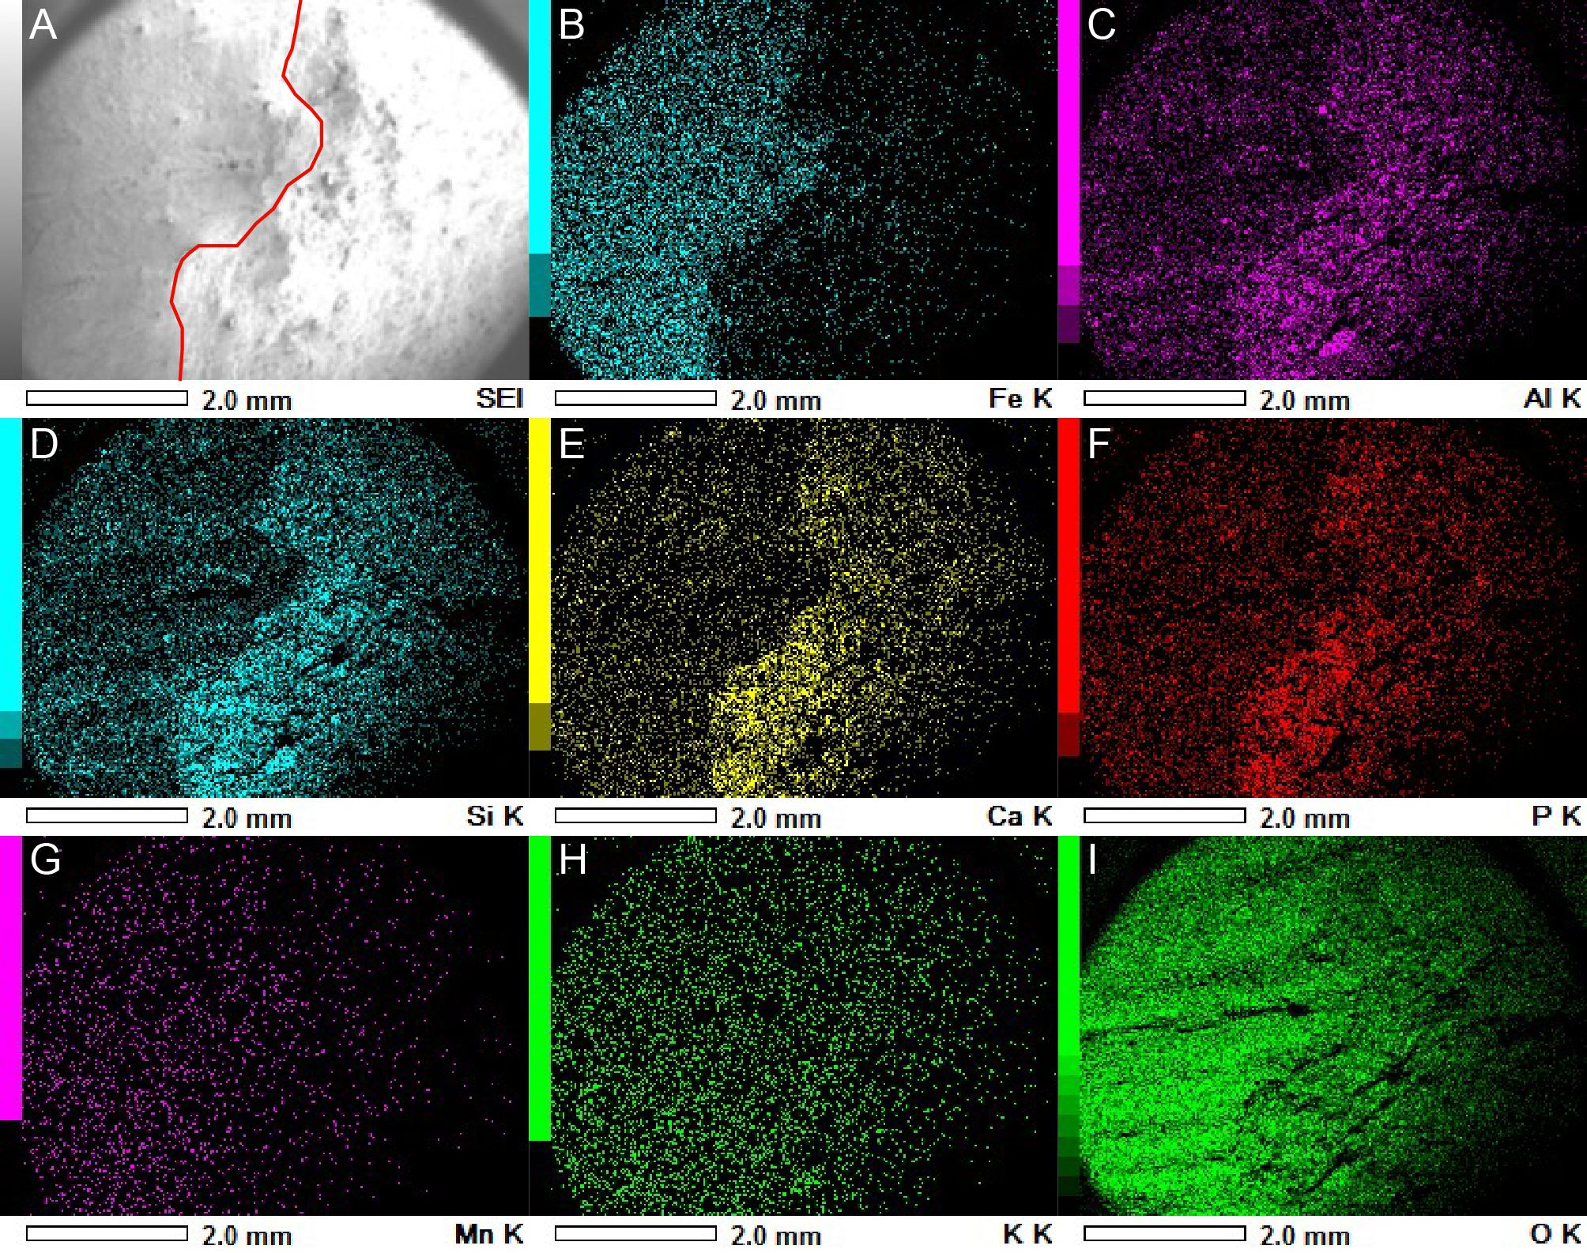
Fig. S1. EDS mapping of strophomenate brachiopod in phosphate concretion. A) Original figure with the interface between the fossil (left of the red line) and the host rock. B) Map of iron. C) Map of aluminum. D) Map of silicon. E) Map of calcium. F) Map of phosphorus. G) Map of manganese. H) Map of potassium. I) Map of oxygen.

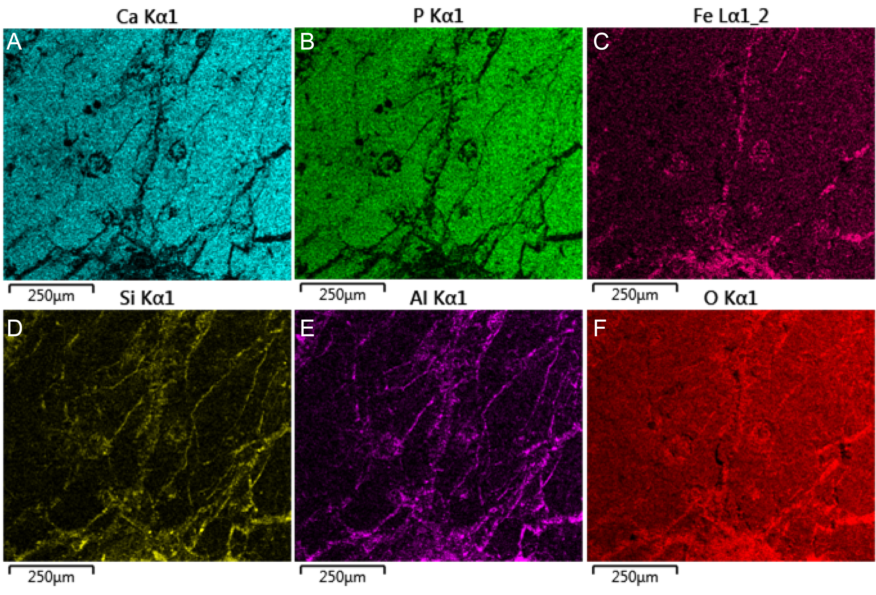
Fig. S2. EDS mapping of a calmoniid trilobite. A) Map of calcium showing higher intensities in the substituted exoskeleton. B) Map of phosphorus. C) Map of iron. D) Map of silicon. E) Map of aluminum. F) Map of oxygen.

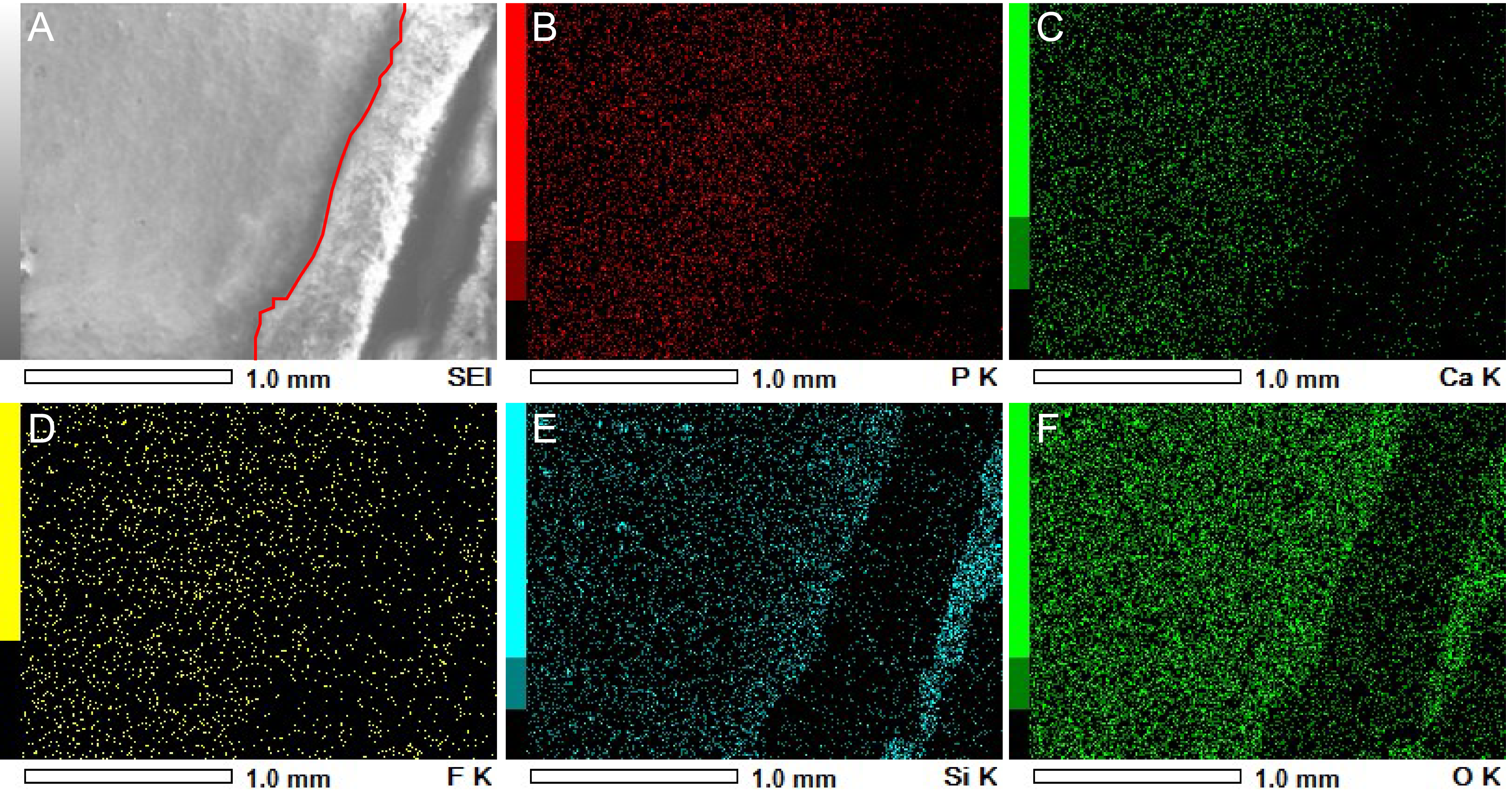
Fig. S3. EDS mapping of the lateral edge of a concretion hosting an orbiculoid. A) Original image with the interface between the edge of the concretion (left) and the edge of the thin section (right). B) Map of phosphorus. C) Map of calcium. D) Map of fluor. E) Map of silicon. F) Map of oxygen.

